Press Release
The following statement was issued by the Central Trade Unions on 3rd July 2020
Nationwide protest by Central Trade Unions on 3rd July, 2020
Against draconian changes in labour laws, privatisation of Govt. departments and PSUs
And for rights of unorganized sector workers

The working class under the banner of central trade unions, and the sectoral federations and association observed Nationwide Protest Day on 3rd July 2020, a massive success throughout the country, in all workplaces and centres as a united struggles of Non-Cooperation and Defiance to anti-worker, anti-farmer, anti-people and anti-national policies of the Govt. The action programmes were organised in almost one lakh places in all states in all work places, union offices, on roads & streets.
In Delhi, the programmes were organised in industrial areas and one programme in front of Shram Shakti Bhawan in which the national leaders of CTUs were present. Those who participated included Ashok Singh from INTUC, Amarjeet Kaur, Vidya Sagar Giri of AITUC, Harbhajan Sidhu from HMS, Tapan Sen, Hemlata & Devroy from CITU, R.K Sharma & Chaurasia from AIUTUC, Rajiv Dimri & Santosh Rai-AICCTU, Lata from SEWA, Shatrujit from UTUC and k leaders of LPF and MEC,leaders of banks and insurance sector.Sanjeev Reddy President, INTUC, Manali Shah-SEWA, Ashok Ghosh-UTUC& Shiv Shankar & Devrajan participated in their respective states. Reports of arrests were received from several areas.
With the opening up of some industrial units, all workers are not being taken back, only a small percentage is finding their place back in jobs and that also on reduced wages and refusal to pay lockdown period salary. Such denial of employment and pressing for wage-reduction have to be unitedly combated.

The jobless are more than 14 crore and if we add the daily wagers/contract/casual, it is more than 24 crores who are out of livelihood at present. The MSMEs themselves are reporting that 30% to 35% units may not be in position to start their activities. The unemployment rate had reached 27% by April. ILO has said in its report that more than 40 crore people would be pushed into deeper poverty. That the malnutrition would increase, hunger deaths would become a daily reality, and there is real threat of depression resulting in suicides amongst workers say the eminent scientists & medical experts. All these issues are enraging workers.

Modi Government has most insensitively dealt with the problem of COVID 19 as law & order issue instead of treating it as medical emergency for the human being and society. It has caused immense miseries to millions of workers, farmers and other vulnerable sections of the society. Whereas, Government stood only by Corporates & big businesses, the unions allege.

The CTUs reiterated their opposition to disinvestment and wholesale privatisation of Public Sector Enterprises, 100 percent FDI in core sectors - Indian railways, Defence, Port and Dock, Coal, Air India, Banks, Insurance Privatisation of Space Science & Atomic Energy etc., steps in favour Corporates of Indian & Foreign brands to usurp natural resources and business of the country while mouthing behind the slogan of Aatma-Nirbhar Bharat. The decision of DA freeze of 48 lakh Central Government Employees and DR freeze of 68 lakh pensioners, which is also having impact on the state government employees, is not withdrawn despite vehement opposition from Government employees and CTUs. Neither the demand of cash transfer of Rs.7500/- to all non-income tax paying persons accepted.

A Government which has no respect and concern, towards the rights and basic survival-entitlements of workers and the people does not deserve any co-operation. We the workers/employees and trade unions need to do everything possible to be in solidarity with each other, unitedly face the disease taking all precautions necessary, stand with each other to defend our rights of unionization, collective bargaining, decent working condition, wages & future securities etc. This Govt has demonstrated cruel insensitivity of the basic human needs of the workers and people. This cannot be endorsed and cooperated with the leaders said while addressing the gathering at Shram Shakti Bhawan.

Later on the Minister of Labour and Employment Shri Santosh Gangwar and Secretary Labour met the leaders of CTUs and accepted their memorandum.

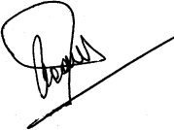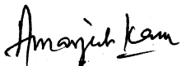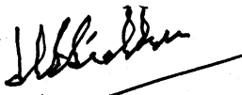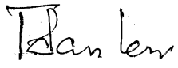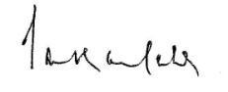
INTUC AITUC HMS CITU AIUTUC
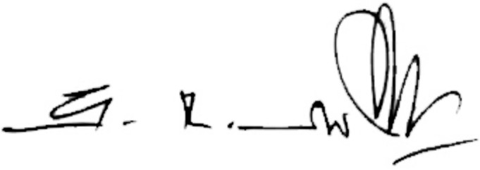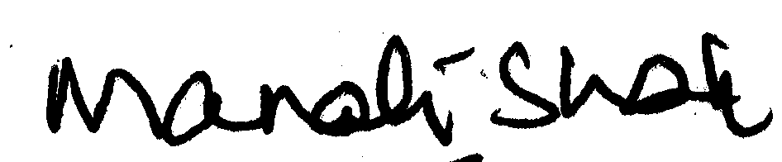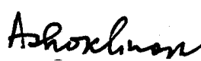
TUCC SEWA AICCTU LPF UTUC

